Network school project

🏫 1️⃣ First: Understand the Building Structure

- Many departments
- Many PCs
- Many servers
- One building
In real life, we design using a hierarchical model:
Internet
|
Router
|
Core Switch
|
-------------------------
| | | | | |
Access Access Access Access Server
SW1 SW2 SW3 SW4 SW
This is called:

🏗 Three-Tier Architecture (Simplified)
- Core Layer
- Access Layer
- End Devices
2️⃣ What Devices To Place (Exact List)

🔹 1 Router (2911)
This connects to the Internet later.

🔹 1 Core Switch (3560 Layer 3)
This is the brain of the network.

🔹 5 Access Switches (2960)
Each one will serve departments.

🔹 1 Server Switch (2960)
3️⃣ How To Organize On Screen
Place devices like this:

TOP CENTER
Router

Below Router (Center)
Core Switch

Left Side (Access Switches)
Access SW1
Access SW2
Access SW3
Access SW4
Access SW5
Right Side
Server Switch

Cable Types (Very Important)
Use:

PC → Switch
Copper Straight-Through

Access Switch → Core Switch
Copper Straight-Through (Gigabit port)

Core Switch → Router
Copper Straight-Through

Tip: How To Check If Cabling Is Correct
After connecting:
- All links should turn green
- If orange → wait 30 seconds (STP)
- If red → wrong port or wrong cable

Data link layer(Layer 2)
Now we move from Physical Layer (Layer 1) to Data Link Layer (Layer 2).
Now the network starts becoming intelligent.
We are going to configure VLANs on the CORE SWITCH (3560).

VLANs must exist on:
- ✅ Core Switch
- ✅ All Access Switches
- ✅ Server Switch
But it starts with the Core.
Go to:
CORE-SW → CLI

🔹 1️⃣ Enter Configuration Mode
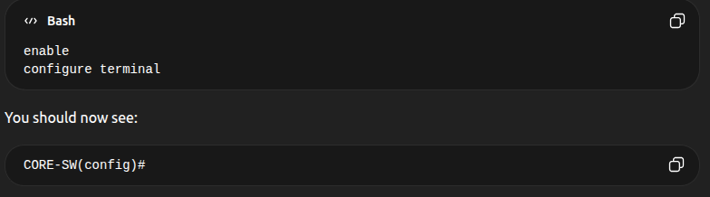

🔹 2️⃣ Create VLANs One by One

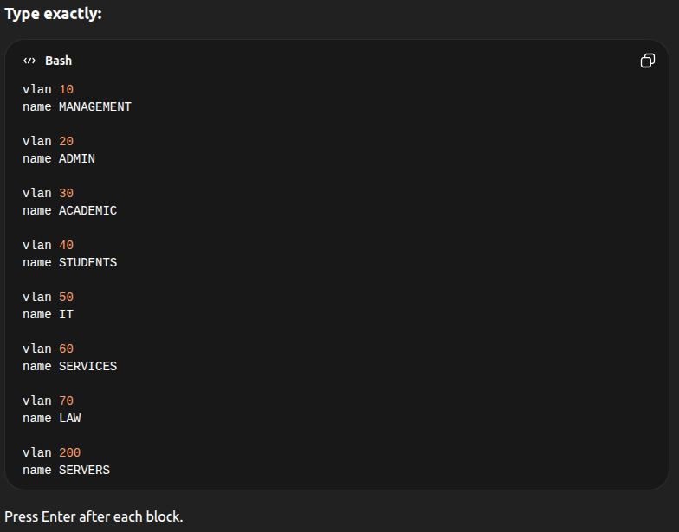

🔎 3️⃣ Verify VLAN Creation
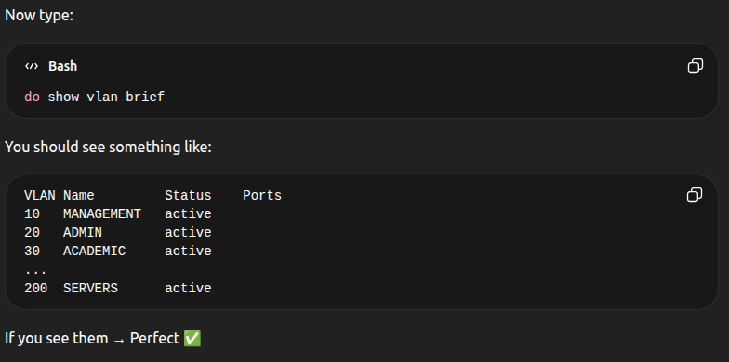

🚨 Important Concept
Right now:
✔ VLANs exist
❌ But no ports belong to them yet
❌ No routing yet
❌ No communication yet
We just created logical containers.
Think of it like:
We built rooms, but no one lives inside yet.

IMPORTANT CONCEPT FIRST
There are 2 types of switch ports:

🔹 Access Port
- Belongs to ONE VLAN
- Used for PCs, printers, servers

🔹 Trunk Port
- Carries MULTIPLE VLANs
- Used between switches
Right now we configure ACCESS PORTS.

Assign VLANs to Access Switch Ports
We DO NOT assign PC ports on the Core.
We configure them on:
- ACC-SW1
- ACC-SW2
- ACC-SW3
- ACC-SW4
- ACC-SW5
- SERVER-SW
Access Switch 1 (Management VLAN 10)
Owners, Directors, Lawyers
Now suppose:
- Fa0/1–Fa0/2 → Owners (2 PCs)
- Fa0/3–Fa0/9 → Directors (5 PCs)
Both belong to VLAN 10 (MANAGEMENT)
Instead of doing one by one, use interface range command:
Type on the CLI:
interface range fa0/1 - 9
switchport mode access
switchport access vlan 10
Access Switch 2 (ADMIN VLAN 20)
Example:
- HR + Accounting + Marketing PCs on Fa0/1 – Fa0/8
Type on the CLI:
interface range fa0/1 - 8
switchport mode access
switchport access vlan 20
Access Switch 3 (ACADEMIC VLAN 30)
Teachers + Library
Type on the CLI:
interface range fa0/1 - 8
switchport mode access
switchport access vlan 30

Access Switch 4
Restaurant → VLAN 60
interface range fa0/1 - 2
switchport mode access
switchport access vlan 60
Access Switch 5

Students → VLAN 40

interface range fa0/1 - 4
switchport mode access
switchport access vlan 40
Access Switch 6
IT → VLAN 50
interface range fa0/1 - 4
switchport mode access
switchport access vlan 50

Access Switch 7
Law_department → VLAN 70
interface range fa0/1 - 3
switchport mode access
switchport access vlan 70

Server Switch
All servers belong to VLAN 200
interface range fa0/1 - 10
switchport mode access
switchport access vlan 200

Configure TRUNK Ports
Right now:
✔ VLANs created
✔ Access ports assigned
But switches cannot pass VLAN traffic between each other yet.
We must configure trunk ports on:
- Each Access Switch uplink
- The Core Switch ports that connect to Access Switches
- The Server Switch uplink

🧠 What Is a Trunk?
A trunk port:
- Carries multiple VLANs
- Connects switches together
- Does NOT belong to one VLAN

STEP 8 — Configure Trunks (Access Switch Side)
On each Access Switch:
Find which port connects to the Core (example: Gi0/1).
Then configure:
interface gig0/1
switchport mode trunk
That’s it.
Repeat on:
- ACC-SW1
- ACC-SW2
- ACC-SW3
- ACC-SW4
- ACC-SW5

- ACC-SW6

- ACC-SW7

- ACC-SW8
- SERVER-SW

STEP 9 — Configure Trunks on Core Switch
Now go to CORE-SW:
For each port connecting to access switches:
Example:
interface range gigabitEthernet1/0/1 - 7
switchport mode trunk
(Adjust the range to match your topology.)

Verify
After configuring, run the IOS command:
show interfaces trunk
You should see something like:
Port Mode Encapsulation Status Native vlan
Gi1/0/1 on 802.1q trunking 1
If you see "trunking" → perfect.

STEP 10 — Create VLAN Interfaces (SVIs)

Where Should VLAN Interfaces (SVIs) Be Created?
You must create them on the Core Switch (3560 Multilayer Switch).
In your topology the device is:
CORE_SWITCH_EN24
Why?
Because the Core switch is performing the routing between VLANs.
So it acts like a router for all VLAN networks.

🏗 What a VLAN Interface (SVI) Does
Each VLAN needs a gateway so devices can send traffic outside their network.
Example:
Students PC:
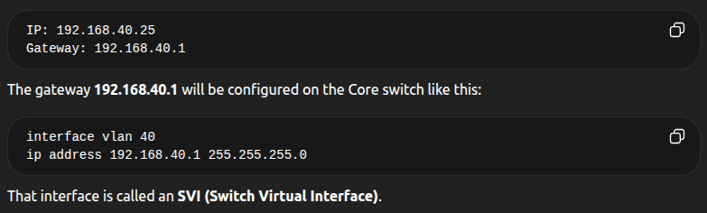

Configuration on CORE_SWITCH_EN24
Execute the following command to each interface vlan below:

VLAN 10

interface vlan 10
ip address 192.168.10.1 255.255.255.0
no shutdown

VLAN 20
interface vlan 20
ip address 192.168.20.1 255.255.255.0
no shutdown

VLAN 30
interface vlan 30
ip address 192.168.30.1 255.255.255.0
no shutdown

VLAN 40
interface vlan 40
ip address 192.168.40.1 255.255.255.0
no shutdown

VLAN 50
interface vlan 50
ip address 192.168.50.1 255.255.255.0
no shutdown

VLAN 60
interface vlan 60
ip address 192.168.60.1 255.255.255.0
no shutdown

VLAN 70
interface vlan 70
ip address 192.168.70.1 255.255.255.0
no shutdown

VLAN 200
interface vlan 200
ip address 192.168.200.1 255.255.255.0
no shutdown

🔎 Verify Configuration
Run this command:
show ip interface brief
You should see something like:
Vlan10 192.168.10.1 up up
Vlan20 192.168.20.1 up up
Vlan30 192.168.30.1 up up
...
Vlan200 192.168.200.1 up up
If you see up/up, everything is correct.😎

🚨 Important Note
If an SVI shows:
up/down
or
down/down
It usually means:
- No active ports exist in that VLAN yet.
But this will fix itself once PCs are active.

Do the DHCP configuration on PCs
Next we will do the DHCP configuration so PCs receive IP addresses automatically.

Recommended for Your Project
Activate DHCP on the Core Switch (3560).
Why?
Because:
- Your Core switch is already doing inter-VLAN routing
- It is the default gateway for all VLANs
- This is common in small/medium enterprise networks
So DHCP and routing stay in the same device.

🧠 Network Logic
Your traffic flow now looks like this:
PC → Access Switch → Core Switch (Gateway + DHCP) → Other VLANs / Servers
The Core switch will:
- Assign IP addresses
- Provide gateway
- Route between VLANs

STEP 3 — Configure DHCP on the CORE SWITCH
Go to:
CORE_SWITCH_EN24
Enter CLI:
enable
configure terminal

First — Exclude Gateway Addresses
We must prevent DHCP from assigning the gateway IP.
ip dhcp excluded-address 192.168.10.1
ip dhcp excluded-address 192.168.20.1
ip dhcp excluded-address 192.168.30.1
ip dhcp excluded-address 192.168.40.1
ip dhcp excluded-address 192.168.50.1
ip dhcp excluded-address 192.168.60.1
ip dhcp excluded-address 192.168.70.1
ip dhcp excluded-address 192.168.200.1

Now Create DHCP Pools

VLAN 10 – Management
ip dhcp pool MANAGEMENT
network 192.168.10.0 255.255.255.0
default-router 192.168.10.1
dns-server 8.8.8.8

VLAN 20 – Admin
ip dhcp pool ADMIN
network 192.168.20.0 255.255.255.0
default-router 192.168.20.1
dns-server 8.8.8.8

VLAN 30 – Academic
ip dhcp pool ACADEMIC
network 192.168.30.0 255.255.255.0
default-router 192.168.30.1
dns-server 8.8.8.8

VLAN 40 – Students
ip dhcp pool STUDENTS
network 192.168.40.0 255.255.255.0
default-router 192.168.40.1
dns-server 8.8.8.8

VLAN 50 – IT
ip dhcp pool IT
network 192.168.50.0 255.255.255.0
default-router 192.168.50.1
dns-server 8.8.8.8

VLAN 60 – Services
ip dhcp pool SERVICES
network 192.168.60.0 255.255.255.0
default-router 192.168.60.1
dns-server 8.8.8.8

VLAN 70 – Law
ip dhcp pool LAW
network 192.168.70.0 255.255.255.0
default-router 192.168.70.1
dns-server 8.8.8.8
⚠️ Do NOT create DHCP for VLAN 200 (Servers)
Servers should have static IP addresses.

Configure DHCP
Now go to a PC:
Desktop → IP Configuration → DHCP(manually)
It should receive something like:
IP address: 192.168.X.X
Gateway: 192.168.X.1
DNS: 8.8.8.8

Verify DHCP on Core
Run:
show ip dhcp binding
This shows which PCs received IP addresses.

After DHCP Works
Next step will be:
Testing Inter-VLAN communication
We will test:
PC (HR) → PC (Teachers)
PC (IT) → Server
Students → Library
This proves the network is fully working.

When you finish the DHCP configuration and run the follow command to check the interfaces:
show ip interface brief
Then we’ll bring the network fully alive.

